Error while combining similar excel files with the same headers



Resolution steps

Goto *Transform file*

Select the content inside the source file

Here the contents are

[Item="Apr 2021 Sales",Kind="Sheet"]

And replace it with a 0

**From**

= (Parameter1) => let

Source = Excel.Workbook(Parameter1, null, true),

#"Apr 2021 Sales_Sheet" = Source{[Item="Apr 2021 Sales",Kind="Sheet"]}[Data],

#"Promoted Headers" = Table.PromoteHeaders(#"Apr 2021 Sales_Sheet", [PromoteAllScalars=true])

in

#"Promoted Headers"

**To**

= (Parameter1) => let

Source = Excel.Workbook(Parameter1, null, true),

#"Apr 2021 Sales_Sheet" = Source{0}[Data],

#"Promoted Headers" = Table.PromoteHeaders(#"Apr 2021 Sales_Sheet", [PromoteAllScalars=true])

in

#"Promoted Headers"





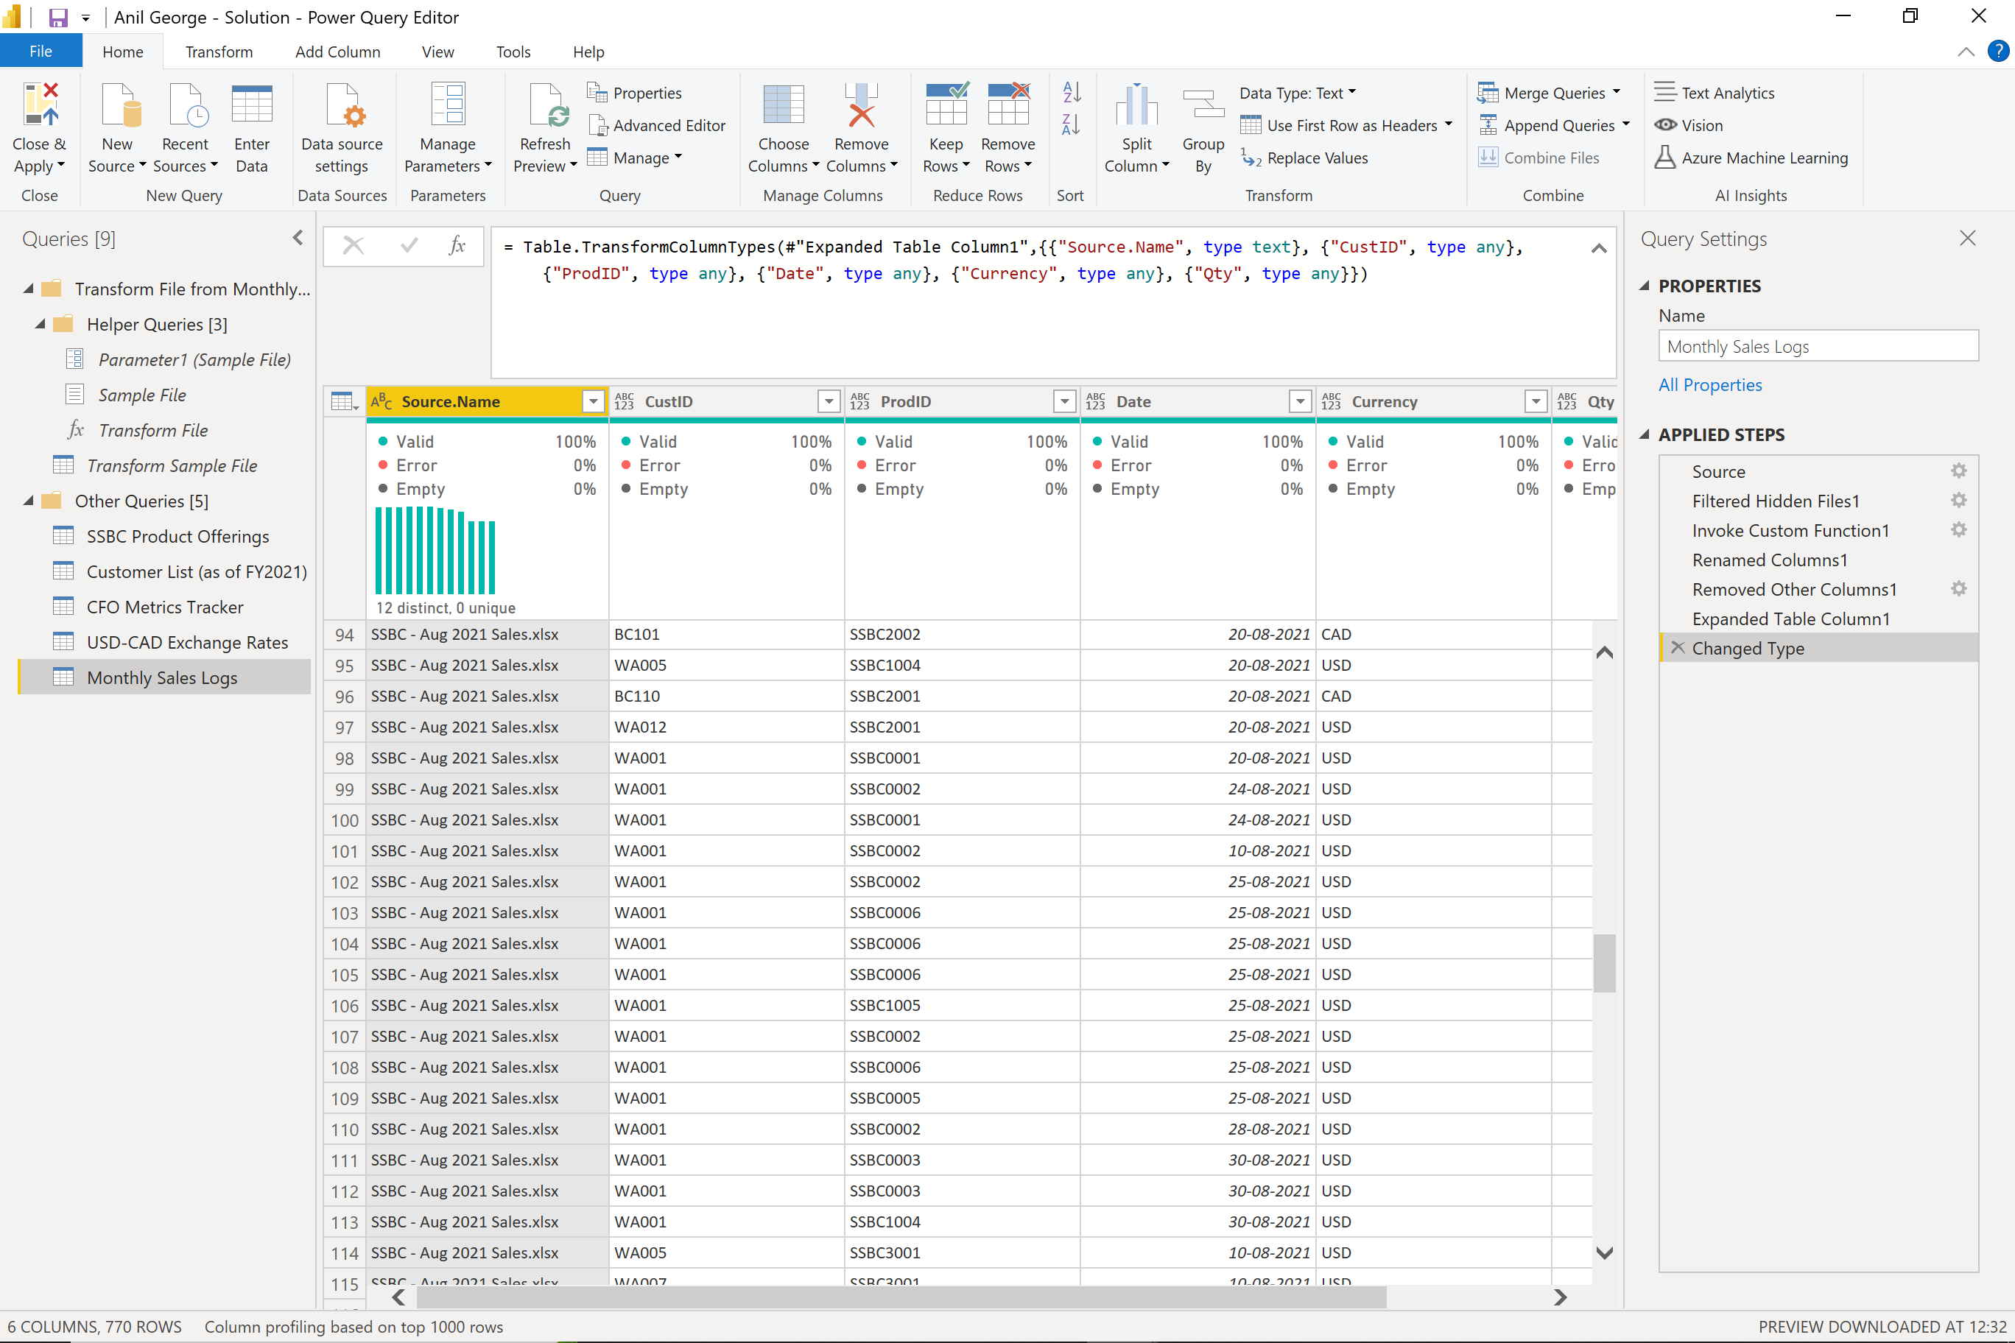

The probable reason might be the Sample File has = Source{0}[Content]

